ABP Modul 13

Nama: Fathan Askar  
NIM: 1301213374  
Kelas: IF-45-04

**A. Codingan**

Modul 13

1.

pubspec.yaml

cart_model.dart

main.dart

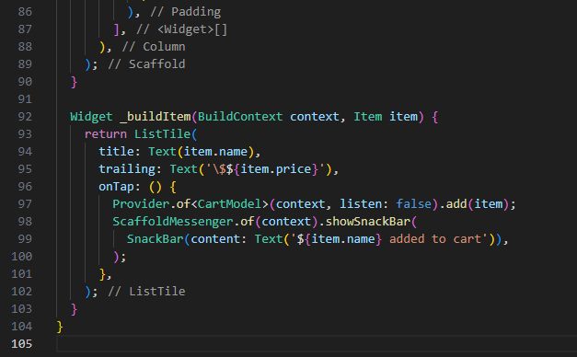

2.

network.dart

main.dart

Eksplorasi Modul 13

network.dart

main.dart

**B. Hasil**

Modul 13

1.

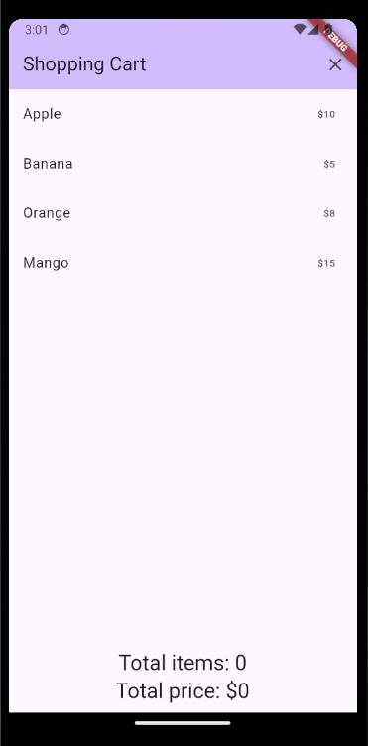

2.

Eksplorasi Modul 13

**C. Analisis/Penjelasan:**

Modul 13